Jefferson County Fire Protection District No. 2

Commissioner Art Frank Commissioner Herbert Beck
Chairman of the Board Commissioner Melody Bacchus

P.O. Box 433, Quilcene, WA 98376 360-765-3333 fax: 360-765-0133

BOARD FOR VOLUNTEER FF/PENSION AND RELIEF BUSINESS: None.

CALL TO ORDER: Chair Commissioner Art Frank called the Regular meeting of the Board of Commissioners to order at 5:00 p.m. The meeting was held of Thursday, April 13, 2020 due to a fire on April 13th. The meeting was also held in the bay with all audience members outside. Chair Commissioner Art Frank, Commissioner Melody Bacchus, Chief Tim McKern, Secretary Jean Morris, David Neuenschwander and Mary Merrill were in attendance.

APPROVAL OF AGENDA: MOTION: Commissioner Art Frank moved to accept the agenda as presented. Commissioner Melody Bacchus seconded the motion. The motion carried with 2 yes votes.

APPOVAL OF MINUTES: MOTION: Commissioner Art Frank moved to accept and sign the minutes of the March 9, 2020 Regular meeting. Commissioner Melody Bacchus seconded the motion. The motion carried with 2 yes votes.

APPROVAL OF VOUCHERS: Upon review of the vouchers prior to the meeting MOTION: Commissioner Art Frank moved to accept the General Fire Vouchers in the amount of $36356.53 and the EMS vouchers in the amount of $24046.68. Commissioner Melody Bacchus seconded the motion. The motion carried with 2 yes votes.

MONTHLY FINANCIAL REPORTS: The monthly financial report was reviewed.

CORRESPONDENCE: Secretary Morris read the list of correspondence.

CHIEF’S REPORTS:

Our Mission
“Provide competent and professional fire, rescue, and medical services to the citizens and visitors of Quilcene and Coyle while ensuring the safety, education, and well-being of its members.”

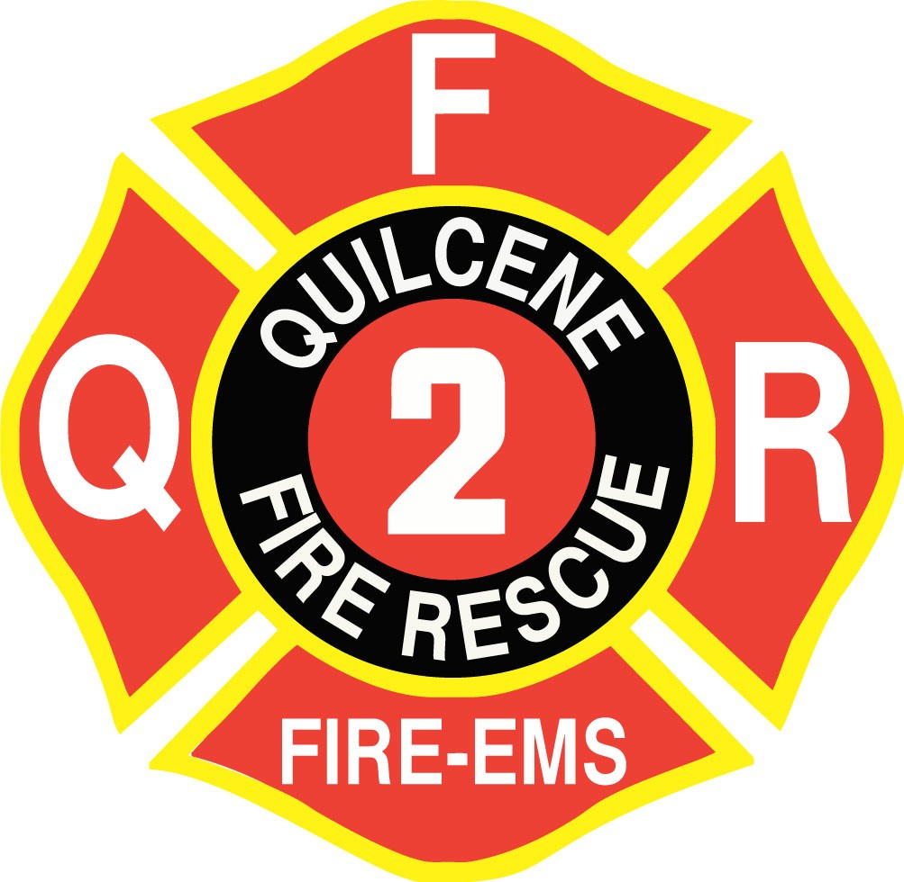
Our Vision

“Provide services to the Quilcene and Coyle communities in the form of fire, rescue and medical incident responses, and public safety, fire prevention and public affairs. These services will be provided in an environment of inclusion of all its members and the communities.”

Our Core Values

The five QFR Core values in priority order are:

QUILCENE FIRE
RESCUE

MONTHLY FIRE CHIEFS REPORT

For April 2020
- FIREFIGHTER SAFETY
- FIRE PREVENTION & PUBLIC EDUCATION
- EFFICIENT OPERATIONS
- PROFESSIONAL BEHAVIOR
- CLEAR POLICY /CONCISE PROCEDURE

“We serve to save”

FIRE CHIEF Tim McKern

Governance and Administration:
    - EMS Training – Pediatric Conference June 4 Port Ludlow Beach Club ALNW/ Jefferson Co. EMS
    - EJFR will be hosting a Child Passenger Safety Technician Class 2/24 – 27/2020 at station 11.
    - Station 21 Construction Project pending construction lift
    - New EMS Protocols complete out for final review and approval will train as we go.
    - Knox Box working on locate and enter into the ERS system
    - COVID 19 Operational Guideline

Goals and Objectives:
    - Station 22 Station and Equipment Repairs
    - PPE inventory ongoing / AFG Grant – pending
    - Radio and Pager inventory / pending
    - Review of VFIS Insurance renewal in next few months review with Gordon soon.
    - Target Solutions on-line training program- We can use for 90 days if needed
    - ESO Medical Billing program- 2021
    - On-going Community Communication with COVID Crisis
    - Inventory Control Supply and Demand

Financial Resources:
    - BIAS – Did a pay roll live with Jean and Dave
    - GEMT review and update with System Design.
    - Reviewing the PILT and School per student revenue that County receives – Moving forward with a letter from legal

Physical Resources and Quality of Life (QOL):
    - Microsoft Office-VPN LT Winn-Ongoing
    - Residence home and ADA- Ramp and Admin going to start any time now – TBD
    - Station 21 paint and windows to be started after above items completed - TBD

Health and Safety
    - Industrial Hygienist-Department of Labor & Industries (10/2): Initial visit completed. Executive Summary attached. We have contacted the door company to sure the door systems. The fan and doors need adjusted.
    - Volunteer physicals -Looking into another clinic and annual Respiratory Questionnaire
    - Review of Exposure Control and Safety programs – This is on-going with Lexapol and our policies.

Essential Resources
    - Policy & Procedure- Lexipol- QFR Policy consolidation ongoing and review critical ones for daily OPS

External Relationships
    - Company Officer Blue Card ICS Training-Ongoing
    - Worked in County EOC one day a week during this crisis.
    - HR with Coyle Cert working with County EOC for field Hospital.

Fire Prevention

Community Risk Reduction programs to start with IFSTA Essentials of CRR programs for staff

Partner with Coyle Community on CERT and DART Program

Deputy Chiefs Report Don Svetich

- Significant Events and Service Delivery:
  - Slow month. Social Distancing or “Physical Distancing”, the new term being used at the state level. Is have an effect on our call volume. Most BLS aid calls, variety of sick people, no known or suspected COVID exposures transported yet. One Structure fire in town on Center, total loss for the family. Large response from our personnel and from the surrounding Departments. Continue to receive three time a week briefing from the State Fire Defense Board. The curve is flattening, the peak for us around the 20 of April and should start declining. The State response ramps up and continues, confirmed cases continue to increase. Possible major impact on the wildfire response if the operational tempo for COVID continues at this rate. Staffing needs each day are being met.

- Apparatus Readiness: See, Lt. McCrehin’s report will cover any additional Apparatus status. EMS units are in service.
Vehicle Replacement Plan (2018-2045), Due for yearly review and updating.

Training and Competency
  - All large-scale EMS and Fire Training Cancelled for the next Month and Half. Due to the COVID 19 Incident.
  - Will be attempting to some online refresher classes.
  - EMS Connect: Working with the Staff and EMS instructors to ensure that we have the best possible training for the Department EMTs.
  - JEFFCO Training Consortium status: No Updates: Discussed Target Solutions with Chief McKern. Waiting Board approval for expenditure to move into Target Solutions.

- Emergency Medical Services:
  - GEMT: Ground Emergency Medical Transportation:
- See Jean’s reports for totals on GEMT.

- Human Resources and Staffing (next 60 days)
- Anticipated time out of the office {AL}No time scheduled. Had to cancel weeklong trip to the Oregon Coast, they close the campgrounds. Will be taking a day or two here and there.
- Have had one member go thru testing for Covid 19 and have several on limited duty status, they met some of the high-risk criteria.

5. Historical Call numbers for each year:
  - Finished 2019 with 530 total calls for Service.
  - Calls for Service, Month of March 2020, 36. Total Year to Date 118.

INCIDENT TYPE | Incident Status | # INCIDENTS
Zone: 21 - Quilcene
111 - Building fire | Reviewed | 1
112 - Fires in structure other than in a building | Reviewed | 1
114 - Chimney or flue fire, confined to chimney or flue | Reviewed | 1
321 - EMS call, excluding vehicle accident with injury | Reviewed | 12
321 - EMS call, excluding vehicle accident with injury | Completed | 1
480 - Attempted burning, illegal action, other | Reviewed | 1
600 - Good intent call, other | Reviewed | 1
651 - Smoke scare, odor of smoke | Reviewed | 1
Zone: 22 - Coyle
114 - Chimney or flue fire, confined to chimney or flue | Reviewed | 1
321 - EMS call, excluding vehicle accident with injury | Reviewed | 2
321 - EMS call, excluding vehicle accident with injury | Completed | 1
Zone: 23 - Dabob
322 - Motor vehicle accident with injuries | Reviewed | 1
Zone: 24 - Out Of District
131 - Passenger vehicle fire | Reviewed | 1
321 - EMS call, excluding vehicle accident with injury | Reviewed | 1
321 - EMS call, excluding vehicle accident with injury | Incomplete | 1
322 - Motor vehicle accident with injuries | Reviewed | 1
611 - Dispatched & cancelled en route | Reviewed | 8
 |  | 36

INCIDENT TYPE | MAR | TOTAL
Fire | 5 | 5
Good Intent Call | 10 | 10
Hazardous Condition (No Fire) | 1 | 1
Rescue & Emergency Medical Service Incident | 17 | 17
Total | 33 | 33

7. Other: End of Report.

A-Shift Officers Report Lt. Mark McCrehin

A-SHIFT OFFICERS REPORT LT. Mark McCrehin

- Apparatus Readiness:
- NKFR has completed the Annual NFPA Inspection for E21. The apparatus is currently at Freightliner to complete the repair on the brake system. To recap: The brakes on E21 have had to be replaced every year (rear brakes only). After further inspection it was determined that the rear axle is the largest available, so it has the largest air cans available. The front axle is not as large, so the air cans are smaller as well. This resulted in too much braking power to the rear axle and not enough to the front. This is a manufacturing error.

After this repair is completed, E21 will be returning to Station 21 and E22 will return to Station 22.

- Training and Competency:

- Department training has been postponed due to COVID-19. However, online training is continuing. This includes, EMS Connect, Blue Card
- Happy to report that all 4 of the students QFR hosted in the last EMT class have all taken and passed their final exam for the class. This completes the class. Unfortunately, all students are waiting for schools to reopen to be able to schedule their NREMT tests.

- Physical Resources and Quality of Life:
- Repairs and improvements have been postponed due to COVID-19
- The Cascade System which we use to refill our SCBA bottles has undergone maintenance and testing.

- Staffing (next 30 days):

- Once again volunteers are supporting a full calendar for the month of April.
- A secondary list has been established for volunteers to man the station if the Duty crew becomes overwhelmed in the coming month due to the current pandemic.

B-Shift Officers Report Lt. Kevin Winn

B-Shift Officers Report Lt. Kevin Winn
- Significant Events and Service Delivery:
- Responded CPR in progress on 02/07.

- Training and Competency:
- The Mason County IV Tech Class Lynne and I were attending has been postponed until after the COVID-19 Pandemic is over.

- I am working with PLFR’s PM Dan Wagner to set up training for the new I-Gel Airway and medications that were given to EMTs in the new Protocols.

- Physical Resources and Quality of Life:
- The AFG Grant I was working with Chief and Bob for new radios and pagers has been submited.

- Action Communication outfitted the New Chief rig with radios.

- Lynne and I have completed the volunteer onboarding timeline and training agreement and it is currently in use.

- We are continuing to monitor the Coronavirus Pandemic in our area, statewide, nationally and globally. We have developed procedures for treating pts with COVID-19 symptoms and have PPE available for use as the Pandemic progresses in the coming weeks and months.
- Staffing (next 60 days):
- I have no vacation or PTO planned for the month of April.

C- Shift Officers Report LT Nick Singleton

- Significant Events and Service Delivery:
- C-Shift had a low call volume for the month of March with notable incidents of a vehicle fire on Mount Walker and a traffic collision on Center Rd.

- Apparatus Readiness:
- C-Shift started the rotation of the first out aid cars. The GMC was rotated into the first out position on 3/15 and the Dodge will have been rotated back into service at the time of this report. The list of items that need to be moved between the aid cars is not extensive. However, there are a few small items that could be purchased to streamline the rotation and I will be working with Chief McKern as well as the other Lieutenants to accomplish this.
- I have been working with Deputy Chief Svetich to place multiple wildland equipment and PPE orders. Included in this order was multiple Quarter Turn hose adapters and backpack water bladders. The adapters and bladders have been placed on both brush rigs.
- Updated map books in both aid cars with most current county maps from public works. Also included in these map books are MedEvac landing zones for all 5 districts and contact info for Coyle property owners.

- Training and Competency:
- Continue to study the updated EMS protocols and will be working with the PLFR C-Shift medic to receive training on our new skills and continuous training.
- Blue card training in complete.
- Continuing to work through modules on EMSConnnect.
- FF Torres and I have been reviewing most data on Covid-19 and have a plan in place for response to a possible Codiv-19 patients

- Physical Resources and Quality of Life:

- I have located some bolt cutters and placed them on A212, this is one less item that needs to be moved for the transition.
- As stated above, we received items from DNR. One of these orders was on a Phase 1 grant and allowed items to be purchased at a 50% discount, most of which was PPE. It has been inventoried is waiting to be issued.

- Staffing (next 60 days):
UNFINISHED BUSINESS:
1. Budget and accounting (Bias): Tabled until next month.
2. Station 22: Tabled until next month.
NEW BUSINESS:
1. RESOLUTION #2020-02. Declaration of Emergency -Covid 10: MOTION: Commissioner Art Frank moved to accept and sign Resolution #2020-02. Commissioner Melody Bacchus seconded the motion. The motion carried with 2 yes votes.

ADJOURNMENT: Chair Commissioner Art Frank Called for adjournment at 5:20 pm.

SIGNED for Jefferson County Fire Protection District No. 2

BY:______________________________________________
ART FRANK, Commissioner, Chair of the Board

BY:______________________________________________
HERBERT BECK, Commissioner

BY:______________________________________________
MELODY BACCHUS, Commissioner

ATTEST
BY:____________________________________________________
Helen Jean Morris, District Secretary

