Jefferson County Fire Protection District No. 2

Commissioner Art Frank Commissioner Herbert Beck
Chairman of the Board Commissioner Melody Bacchus

P.O. Box 433, Quilcene, WA 98376 360-765-3333 fax: 360-765-0133

BOARD FOR VOLUNTEER FF/PENSION & RELIEF BUSINESS: None.

CALL TO ORDER: Chair Commissioner Art Frank called the Regular meeting for Board of Commissioner of May 11, 2020 to order at 7:00 pm. Chair Commissioner Art Frank, Commissioner Melody Bacchus, Commissioner Herbert Beck (via phone), Thane Grooms, Mary Merrill, Abby Ward, Mark McCrehin, Chief Tim McKern, Secretary Jean Morris, Don Svetich and David Neuenschwander were in attendance.

PLEDGE OF ALLEGIENCE: The Pledge of Allegiance was said.

APPROVAL OF AGENDA: MOTION: Commissioner Art Frank moved to accept the agenda with the deletion of 2. Chief’s revised contract under New Business. Commissioner Melody Bacchus seconded the motion. The motion carried with 3 yes votes.

APPROVAL OF MINUTES: MOTION: Commissioner Melody Bacchus moved to accept and sign the minutes of the April 16, 2020 Regular meeting. Commissioner Art Frank seconded the motion. The motion carried with 2 yes votes. Commissioner Herbert Beck was absent at that meeting.

APPROVAL OF VOUCHERS: Upon review of the voucher prior to the meeting MOTION: Commissioner Art Frank moved to accept and sign the General Fire Vouchers in the amount of $59,173.93 and the EMS Vouchers in the amount of $17,337.93 as presented. Commissioner Herbert Beck seconded the motion. The motion carried with 3 yes votes.

MONTHLY FINANCIAL REPORT: The Monthly Financial Report was reviewed.

CORRESPONDENCE: Secretary Morris read the list of monthly correspondence.

CHIEF’S REPORT & OFFICER REPORTS:

Our Mission
“Provide competent and professional fire, rescue, and medical services to the citizens and visitors of Quilcene and Coyle while ensuring the safety, education, and well-being of its members.”

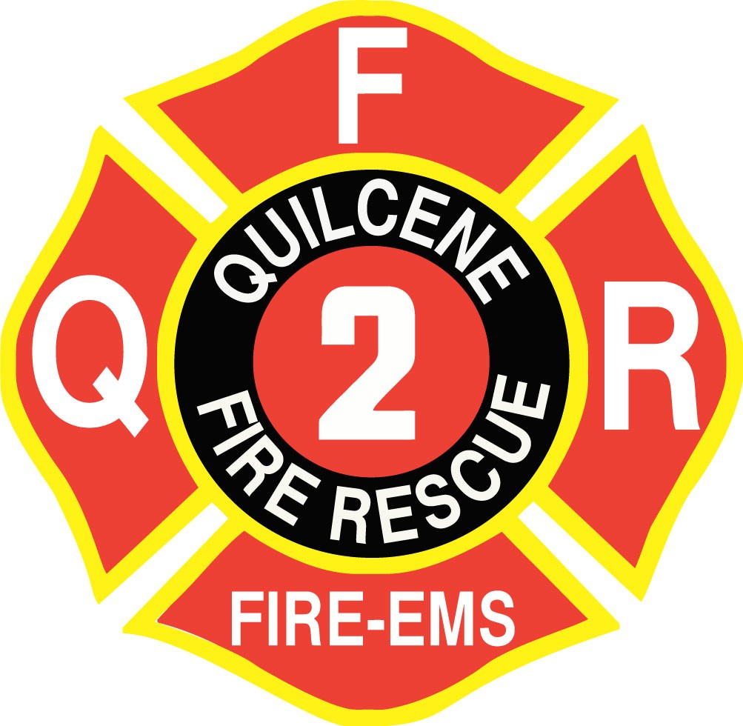
Our Vision

“Provide services to the Quilcene and Coyle communities in the form of fire, rescue and medical incident responses, and public safety, fire prevention and public affairs. These services will be provided in an environment of inclusion of all its members and the communities.”

Our Core Values

The five QFR Core values in priority order are:

QUILCENE FIRE
RESCUE

MONTHLY FIRE CHIEFS REPORT

For May 2020
- FIREFIGHTER SAFETY
- FIRE PREVENTION & PUBLIC EDUCATION
- EFFICIENT OPERATIONS
- PROFESSIONAL BEHAVIOR
- CLEAR POLICY /CONCISE PROCEDURE

“We serve to save”

FIRE CHIEF Tim McKern

Governance and Administration:
    - Station 21 Construction Project Station 21 Painting and Admin ADA ramp on-going.
    - New EMS Protocols complete out for final review and approval will train as we go.
    - COVID 19 Operational Guideline on-going
    - On-going Facebook Live weekly and will go to once a month on Tuesday after board meeting.

Goals and Objectives:
    - Station 22 Station and Equipment Repairs
    - PPE inventory ongoing / AFG Grant – pending
    - Radio and Pager inventory / pending
    - Review of VFIS Insurance renewal in next few months review with Gordon soon.
    - Target Solutions on-line training program- We can use for 90 days if needed
    - ESO Medical Billing program- 2021
    - On-going Community Communication with COVID Crisis
    - Inventory Control Supply and Demand

Financial Resources:
    - BIAS – Due to training and current situation move to 2021
    - GEMT review and update with System Design. Surcharge for COVID
    - Reviewing the PILT and School per student revenue that County receives – Moving forward with a letter from legal Still pending

Physical Resources and Quality of Life (QOL):
    - Microsoft Office-VPN LT Winn- Completed for Jean and Chief
    - Jefferson County Re-Opening of the County and what that means to us?

Health and Safety
    - Industrial Hygienist-Department of Labor & Industries (10/2): Initial visit completed. Executive Summary attached. We have contacted the door company to sure the door systems. The Doors at Station 21 have been adjusted with new openers adjusted fan turn-on for each door.
    - Volunteer physicals -l Respiratory Questionnaire going to be done with Manette Clinic (Debbie Tillman) here at Station 21
    - Review of Exposure Control and Safety programs – This is on-going with Lexapol and our policies.

Essential Resources
    - Policy & Procedure- Lexipol- QFR Policy consolidation ongoing and review critical ones for daily OPS

External Relationships
    - Company Officer Blue Card ICS Training-Ongoing
    - Worked in County EOC one day a week during this crisis.
    - HR with Coyle Cert working with County EOC for field Hospital.

Fire Prevention

Community Risk Reduction programs to start with IFSTA Essentials of CRR programs for staff

Partner with Coyle Community on CERT and DART Program

Deputy Chiefs Report Don Svetich

Significant Events and Service Delivery:
  - Average month. Most BLS aid calls, variety of sick people, vehicle accidents, one structure fire, boat fire and a vehicle fire. The structure was on McDonald Road: two storied, residence that had a chimney fire that had gotten into the walls and ceiling. A very good response from the Department; Chief McKern, Lt. Winn and nine volunteers: Goodrich, TJ & TA Svetich, Blackburn-Cassella, Coryell, Edwards, Frank, M. McCrehin and Torres. Heavy damage to the B side exterior wall and chimney shell. We were able stop lose on the remainder of the residence. Had a vehicle fire on Leland Valley Road, vehicle was a 1980’s Chevy pick-up, owner was able to contain the fire until E21 and Lt. Singleton arrived on scene, fire contained to the engine compartment. E21 with Lt. McCrehin was dispatched to Port Ludlow Marina for a boat fire in a 40+ foot motor cruiser.
- Apparatus Readiness: Lt. McCrehin’s report will cover any additional Apparatus status.
Vehicle Replacement Plan (2018-2045), See attached graph, for a list. This is intent for discussion at a later date.

- Training and Competency
  - All large-scale EMS and Fire Training Cancelled for the next Month and Half. Due to the COVID 19 Incident. Small scale and mission critical training will continue
  - EMS Connect: Ongoing evaluation.
  - JEFFCO Training Consortium status: Large scale training events on hold. Currently working on the logistics for MCO training in the future.
- Emergency Medical Services:
  - GEMT: Ground Emergency Medical Transportation:
- Jean has totals in the financial report.
4. Historical Call numbers for each year:
  - Finished 2019 with 530 total calls for Service.
  - 37 Calls for Service, Month of April 2020.

INCIDENT TYPE | Incident Status | # INCIDENTS
Zone: 21 - Quilcene
111 - Building fire | Reviewed | 1
131 - Passenger vehicle fire | Reviewed | 1
321 - EMS call, excluding vehicle accident with injury | Reviewed | 15
322 - Motor vehicle accident with injuries | Reviewed | 1
324 - Motor vehicle accident with no injuries. | Reviewed | 1
554 - Assist invalid | Reviewed | 1
611 - Dispatched & cancelled enroute | Reviewed | 1
622 - No incident found on arrival at dispatch address | Reviewed | 1
651 - Smoke scare, odor of smoke | Reviewed | 1
Zone: 22 - Coyle
321 - EMS call, excluding vehicle accident with injury | Reviewed | 2
600 - Good intent call, other | Reviewed | 1
Zone: 23 - Dabob
321 - EMS call, excluding vehicle accident with injury | Reviewed | 1
Zone: 24 - Out of District
134 - Water vehicle fire | Reviewed | 1
322 - Motor vehicle accident with injuries | Reviewed | 1
611 - Dispatched & cancelled enroute | Reviewed | 8

INCIDENT TYPE | APR | TOTAL
Fire | 3 | 3
Good Intent Call | 12 | 12
Rescue & Emergency Medical Service Incident | 21 | 21
Service Call | 1 | 1
Total | 37 | 37

- Human Resources and Staffing: Remains stable, meeting each incident needs.
- Anticipated time out of the office: May 27 to June 3, 2020. Will be in Boise ID, to take care of my Mother
- 6. Other: Any Questions? End of Report

A-SHIFT OFFICERS REPORT LT. MARK MCCREHIN
Apparatus Readiness:
E21 is currently still at Freightliner. NKFR spoke with the engineers and mechanics at Freightliner. Engineers insist that the current brake setup is correct. Freightliner is going to be replacing the current brakes and then it will be returned to us. NKFR would like to have the engine back in 6 months to recheck the brakes to make sure that they are wearing correctly.
Training and Competency:
Department training has been postponed due to COVID-19. However, online training is continuing. This includes, EMS Connect, Blue Card
Our new EMT student, Sophia Knutzen has passed her NREMT exam. There are 2 students left that have tests scheduled in May.
Physical Resources and Quality of Life:
Painting Station 21 has resumed. Painters are expected to be done soon.
AA Complete Construction has begun work on the ADA ramp for the Admin building. Crews are currently in the demolition stage.
Staffing (next 30 days):
The Duty Calendar for May is once again full. Several days with a 3 ^{rd} person

B-Shift Officers Report Lt. Kevin Winn

- Significant Events and Service Delivery:
- Responded to a residential structure Fire on 02/07.

- Training and Competency:
- The Mason County IV Tech Class has started back up again, and Lynne and I will be done with the class on May 14th.

- Physical Resources and Quality of Life:
- We have received a new BK radio from the DNR Cash LT Singleton put together and it is in service on B21.

- We are continuing to monitor the Coronavirus Pandemic in our area, statewide, nationally, and globally.

- Chief and Jean have been set up with remote access to their work computers so they have the ability to work from home if needed.
- Staffing (next 60 days):
- I have no vacation or PTO planned for the month of May.

C- Shift Officers Report LT Nick Singleton

- Significant Events and Service Delivery:
- C-Shift had a relatively low call volume for the month of April with a notable incident of a mutual aid motorcycle accident in District 4. A21 assisted district 4 crew with airlifting a critical patient.
- Water usage report submitted to PUD- approx. 5000 gallon used between incidents, training, nd maintenance.

- Apparatus Readiness:
- I have added 4 4x4 crib blocks to E22 for stabilization of vehicles and plan to upgrade the cribbing on E21 with new lumber when it returns. FF Zak Torres did an excellent job at creating a way to secure some handles on the crib blocks for safety.
- The annual service on E22’s mounted generator is complete with no issues.
- The annual service on T21’s portable pump is complete, thanks to Volunteer Jim Pinks for fixing the issue with the carburetor.
- The annual service on E21’s PPV fan is complete with no issues.
- I ordered some ¾’’ toy hose for the brush rigs as we had none in stock at the station.
- B22 has been outfitted with more hose adapters and a foot valve for the hard suction hose for drafting water.
- We have received a new DeWALT tool kit that was ordered from home depot. Included in this kit is tools that will help with station chores, an upgraded Sawzall for E21, and additional tools that will assist in service calls, rescues, and vehicle extrications. I am planning on putting together an extrication kit for all of these tools and will update the department when it is complete.
- We have received the new STIHL MS261 chainsaw. It has been inventoried and placed in service on E21. The older STIHL chainsaw will be assigned to E22.

- Training and Competency:
- Attended EMS virtual conference put on by the Oregon health authority and received an additional 16 hours of EMT CE credits within the span of two weeks.
- Have been assisting Zak and Damon with preparation for their NREMT test. Their tests have been scheduled.
- Continuing to work through modules on EMSConnnect.
- Zak Torres and I have been training a significant amount on Wildland subjects. C Shift Completed its RT-130 Wildland refresher which was an all-day training. Zak and I have a plan to continue to review lessons learned from wildfire incidents by reading the material and discussing the near misses or fatalities. We also have a plan to observe and document weather a couple times per shift. This will help develop our skills with the belt weather kit and provide information we can share.
- With the help of Deputy Chief Svetich, I will be putting together a wildland training outline for our Coyle division and working with Thane Grooms for Scheduling a day. The goal is to provide some fundamental training for the Coyle division by the end of the month.
- I have started Damon Edwards on the EVIP 3.0 classroom training

- Physical Resources and Quality of Life:

- Please see above.

- Staffing (next 60 days):
- NTR.

- Other:
UNFINISHED BUSINESS
1. Budget and accounting (Bias): This item was moved to 2021.
2. Station 22: Working on well. Power washing building this week-end.

NEW BUSINESS:
1. Add Chief to U.S. Bank accounts: MOTION: Commissioner Art Frank moved to add Chief Tim McKern to all U.S. Bank accounts. Commissioner Herbert Beck seconded the motion. The motion carried with 3 yes votes.

ADJOURNMENT: Chair Commissioner Art Frank called for adjournment at 7:06.

SIGNED for Jefferson County Fire Protection District No. 2

BY:______________________________________________
ART FRANK, Commissioner, Chair of the Board

BY:______________________________________________
HERBERT BECK, Commissioner

BY:______________________________________________
MELODY BACCHUS, Commissioner

ATTEST
BY:____________________________________________________
Helen Jean Morris, District Secretary

